Please enter the relevant fields in ‘File/Properties’, ‘Summary’ tab.
Complete the table below, using only one A4 page.
Contractual Date of Delivery to the EC: | [ISO format]
Actual Date of Delivery to the EC: | [ISO format]
Workpackage:
Author(s) and Institutions
Estimated Staff Months:
Dissemination Level:
Nature: | [eg a report, or software …]
Approval Status:
Version:
Total Number of Pages: | 38
Filename: | KS-AP3.4.11-12-UEP-2006-08-30-Survey on modelling upper Ontologies-v1.1.doc
Keyword list:
Abstract

The information in this document reflects only the author’s views and the European Community is not liable for any use that may be made of the information contained therein. The information in this document is provided as is and no guarantee or warranty is given that the information is fit for any particular purpose. The user thereof uses the information at its sole risk and liability.

History

Version | Date | Reason | Revised by
1.0 | 30/06/06 |  | M.Vacura
1.1 | 30/08/06 | Addition of existing upper ontologies comparison. | M.Vacura

Authors

Partner | Name | Phone / Fax / Email
UEP | Miroslav Vacura | vacuram@vse.cz
CWI | Raphael Troncy

Table of Contents

1 Executive Summary 4
2 Abbreviations and Acronyms 5
2.1 Glossary 6
3 Introduction 7
3.1 The FRBR model and methodology. 8
3.1.1 Methodology 8
3.1.2 Conceptual model 9
3.1.3 Group 1 entities 9
3.1.4 Group 2 entities 10
3.1.5 Group 3 entities 11
3.1.6 Examples 13
3.1.7 Usage and evaluation 14
3.2 The (CIDOC)-CRM model 15
3.2.1 Conceptual model 15
3.2.2 Usage and evaluation 18
3.3 The ABC ontology and model 20
3.3.1 Conceptual model 21
3.3.2 Examples 23
3.3.3 Usage and evaluation 25
4 Conclusion 26
5 References 27

Executive Summary

Abbreviations and Acronyms

FRBR - Functional Requirements for Bibliographic Records

ISBD - International Standard Bibliographic Descriptions

GSARE - Guidelines for Subject Authority and Reference Entries

AITF - Art Information Task Force

VRA – Visual Resources Association

CIDOC - International Committee for Documentation

ICOM - International Council of Museums

CRM - Conceptual Reference Model

IFLA – International Federation of Library Associations

OWL – Ontology Web Language

XML – Extended Markup Language

RDF – Resource Description Framework

RDFS – RDF Schema

DTD – Document Type Definition

W3C – World Wide Web Consortium

AMOL - Australian Museums Online

CIMI - Consortium for Interchange of Museum Information

Glossary

Introduction

The FRBR model and methodology.

The Functional Requirements for Bibliographic Records (FRBR) [1] is published by IFLA. It is study analyzing functions performed by bibliographic record and aiming at producing a framework that would define a clear, in precise terms defined understanding of character of what bibliographic record aims to provide information about, and which user needs it should cover.

First step in developing such framework was defining entities of interest, from point of view of users of bibliographic system. Next, for each entity set of important attributes had to be defined, along with definition of types of relations that can operate between entities. Result of such analysis was conceptual model that makes no a priori assumptions about character of bibliographic record itself.

Most important entities, attributes and relations are these that are used by bibliographic systems users in formulating bibliographic searches, reviewing results of these searches and navigating in space of bibliographic system itself. FRBR study focuses not to be exhaustive in terms of covered entities, attributes and relations, but to be comprehensive in scope and tries to operate only on conceptual level and not to descend to level of developing data model. Therefore were basic elements of developed conceptual model derived from logical analysis of bibliographical records and stored data, using following documents: International Standard Bibliographic Descriptions (ISBDs), the Guidelines for Authority and Reference Entries (GARE), the Guidelines for Subject Authority and Reference Entries (GSARE), the UNIMARC Manual, AITF Categories for the Description of Works of Art and also based on consultations with various experts.

Methodology
FRBR methodology is based on technique of an entity analysis that is used in relational database systems for developing conceptual models. Entity analysis begins with effort to isolate the key object in particular domain that are most important to user and then tries to define them as entities at highest possible level. For example in personal information system such key object would be “employee”. Following key entities identification also relations that typically hold between these entities are identified (i.e. employee occupies position).
When entities and their relationships are defined, FRBR focuses on most important characteristics or attributes of entities. Also extension of technique that was used to identify relations between key entities (or more precisely entity types) can be then used to identify possible relations between instances of entities of same type (i.e. spousal relation may hold between two instances of entity type employee).

When entity-relationship structure of bibliographic data was defined, each its component was evaluated according to their relevance to typical tasks of users. Entities and relationships are then mapped to the four most typical user tasks defined in the FRBR study and relative values referencing task performed by user are assigned to each attribute and relationship.

The entity-relationship analysis technique used in FRBR study is based on number of other works [2], [3], [4], [5].

Conceptual model
Although resulting bibliographic model is not directly relevant to K-Space area of research it is an interesting and inspirational model for the modelling of the multimedia ontology. Entities and corresponding attributes and relationships are in FRBR model divided to three separate groups.

Group 1 entities
Key entities identified in first group of conceptual model by FRBR are work, expression, manifestation, item, with following semantic interpretation:

- Work – a distinct intellectual or artistic creation.
- Expression – the intellectual or artistic realization of work.
- Manifestation – the physical embodiment of an expression of a work.
- Item – a single exemplar of a manifestation.

The first two types of entities – work and expression – represent intellectual or artistic content. Second two types of entities – manifestation and item – represent physical form of bibliographic entity.
For these primary entities there are three associated relationships defined:

- work is realized through expression
- expression is embodied in manifestation
- manifestation is exemplified by item

Entities and relationships of first group are shown on Fig. 1.

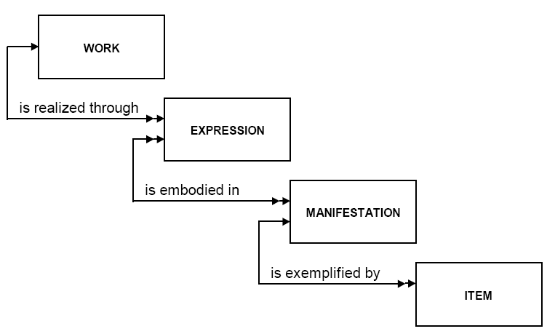

Fig. 1: Entities and relationships of FRBR (diagram reprinted from [1])

Group 2 entities
Key entities identified in second group of conceptual model by FRBR are person and corporate body, with following semantic interpretation:

- Person – an individual (human being).
- Corporate body – an organization or group of individuals and/or organizations.

Between entities in first group and entities in second group four relationships forming complex relationship of responsibility exist as depicted on Fig. 2. These four relationships are:

- is owned by – concerning item
- is produced by – concerning manifestation
- is realized by – concerning expression
- is created by – concerning work

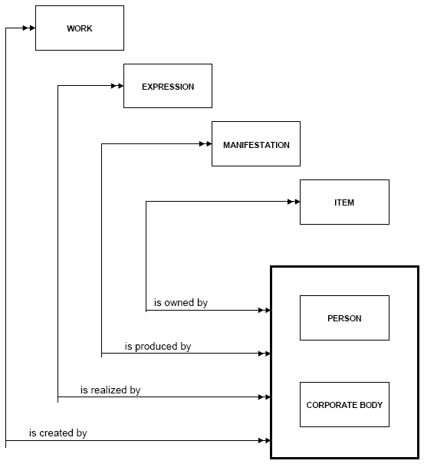
Fig. 2: Responsibility relationships of FRBR (diagram reprinted from [1])

Group 3 entities
Key entities identified in third group of conceptual model by FRBR are concept, object, event and place, with following semantic interpretation:

- Concept – an abstract notion or idea.
- Object – a material thing.
- Event – an action or occurrence.
- Place – a location.

Between entities in first group and entities in third group four relationships forming complex relationship of subject exists as depicted on Fig. 3. This relationship tries to capture notion that i.e. work may have as its subject an object. Or respectively i.e. some place can be subject of some works.

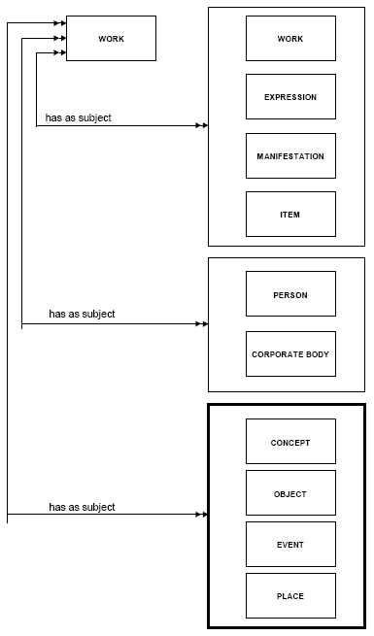
Fig. 3: Subject relationships of FRBR (diagram reprinted from [1])

Examples
Examples of entities of type work, expression, manifestation and item [1]:

Work 1 – Ronald Hayman’s Playback
Expression 1 – the author’s text edited for publication
Manifestation 1 – the book published in 1973 by Davis-Poynter
Item 1 – copy autographed by the author
Work 2 – Allan Wakeman’s Jabberwocky
Expression 2 – the author’s design for the game and text for the notes
Manifestation 2 – the game and accompanying notes for teachers issued in 1974 by Longman
Item 2 – copy lacking notes for teachers

Examples of entities of type person and corporate body [1]:

Person 1 – Margaret Atwood
Person 2 – Hans Christian Andersen
Person 3 – Queen Victoria
Person 4 – Anatole France

Corporate body 1 – Museum of American Folk Art
Corporate body 2 – BBC Symphony Orchestra
Corporate body 3 – Symposium on Glaucoma
Corporate body 4 – Regional Municipality of Ottawa-Carleton

Examples of entities of type concept, object, event and place [1]:

Concept 1 – Economics
Concept 2 – Romanticism

Object 1 – Apollo 11
Object 2 – The Eiffel Tower

Event 1 – The Battle of Hastings
Event 2 – The Age of Enlightenment

Place 1 – The Alacran Reef
Place 2 – Morey Peak Wilderness Study Area

Usage and evaluation
This model is widely used in the Digital Library community. For example, it has been a source of inspiration for the work of Jane Hunter and Karl Lagoze for developing the ABC model (see below).

This model is similar, to some extent, to what VRA [2] has proposed for images, that is, distinguished at the top level the work versus the digital representation (the image) of this work. FRBR could be seen here as a generalization.

The (CIDOC)-CRM model
The CIDOC Conceptual Reference Model (CRM) [7] developed by the International Committee for Documentation (CIDOC) of the International Council of Museums (ICOM) defines formal structure and necessary conceptual definitions for describing concepts and relationships used in cultural heritage documentation, both implicit and explicit. Research and other activities in area of cultural heritage and history are based on the interpretation of primary materials of various types. These primary materials can have form of objects found in excavations, monuments, archaeological sites, historical records and many others. Typical museum can keep up to millions objects. Cultural heritage institutions like museums, archives or libraries need to create and maintain extended documentation about stored objects trying to capture their main features and attributes.

Ambition to store this kind of information in digital form brought up problems regarding obvious difficulty of such project. One physical object can be now described by various types of digital media at the same time – in textual, image, visual or another multimedia form. Also, many institutions already defined their own data formats and hold significant amount of data in these proprietary formats.

CIDOC CRM was defined with following requirements in mind:
- Possibility to have way for defining complementary information like friends of friends, ancestors, matching art objects with work of friends, treaties and political interests etc.
- Supporting relating information in standardized manner, that allows user to search and aggregate objects by various contextual criteria.
- Support for incomplete or scarce information.
- Ability to accommodate different levels of detail or abstraction in which the same things may be documented.
- Ability to aggregate contradictory information.

CIDOC CRM Model presents core ontology for describing semantics of schema and also data structure elements that are used in cultural heritage institutions for documentation of objects that should be compliant with above stated requirements. This model is based on idea, that historical context can be abstracted as things, people and ideas meeting in space-time.
Recently, it has been accepted as an ISO standard and is available as a Final Draft ISO standard (ISO/FDIS 21127).

Conceptual model
CIDOC CRM Model comprises of 80 classes and 130 relationships of the most important characteristics in cultural heritage area.

CRM Core describes only most important characteristics that describe and connect things, people, concepts, people, time and place. Key idea of CIDOC CRM is then modeling of events both as means to:

- Describe metadata – in terms of creation, publication and use.
- Context summarization and creation of integrated knowledge base.

Authors of CIDOC CRM claim that its normal human way of analyzing the past by splitting it up to discrete events. All information about can be therefore defined in terms of events that involve “Persistent items” (that means endurants or pendurants). Such involvement can be of various forms, even abstract or immaterial entities can be involved in some event. CIDOC CRM views history as number of lifelines of Persistent items that meet in discrete events.

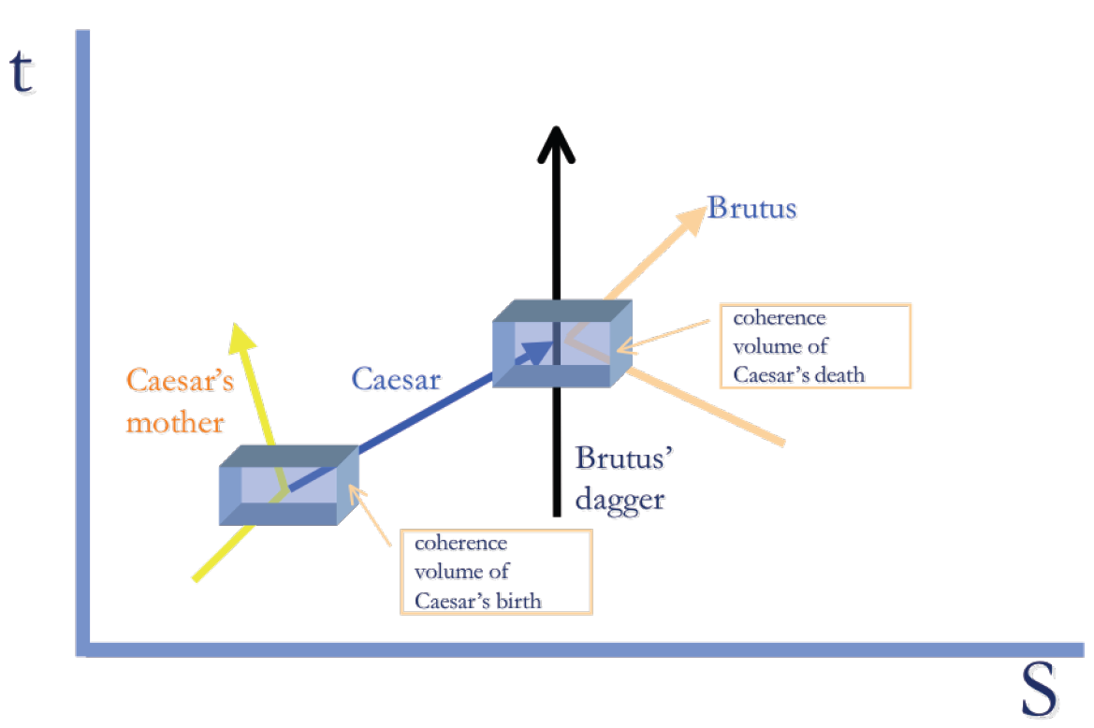
Fig. 4: Example of CIDOC CRM lifeline conceptual model. (diagram reprinted from [7])

As we can see on Fig. 4 murder of Caesar can be interpreted in terms of CIDOC CRM conceptual model as meeting of Caesar, Brutus, Brutus’s dagger and others in same space-time location forming an event. At this event Caesar existence comes to its end while existence of other entities continues.

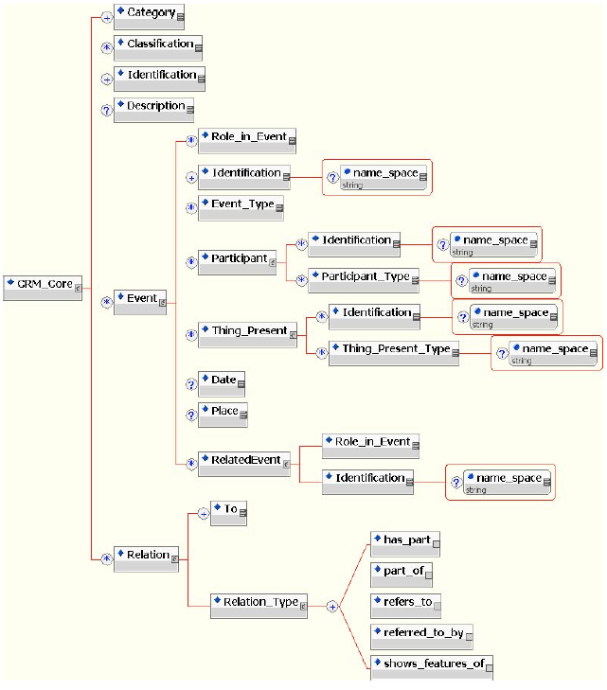

Fig. 5: CIDOC CRM Core ontology (diagram reprinted from [7]).

Most abstract property that formalizes abstract notion described in above example is P12 occurred in the presence of, which is abstraction of other more specific roles that some thing can have in an event. This property is also implicitly present in fields “participants” and “things_present”. CIDOC CRM Core is shown on Fig. 5, where it is possible to see that four fundamental principles of this ontology are:

- participation in events
- part-whole relation
- reference
- classification

Along this, each entity like people, places, objects and institutions is modeled as separate record. Entities that can be involved in events have Participant and Thing_present elements. It is also possible to describe other relations like who is creator, contributor or publisher, and information about birth place, creation date, place of find, designer, project leader and other relationships.

CIDOC CRM can also describe more complex relations like has part or part of allowing user to capture part-whole relationships between entities. Also relations defining referring are allowed in CRM scheme in form of relations refers to and referred to by. Another possible fundamental relation is shows features of. Typical cultural heritage scenario is shown on Fig. 6 – documentation of different views of same physical object.

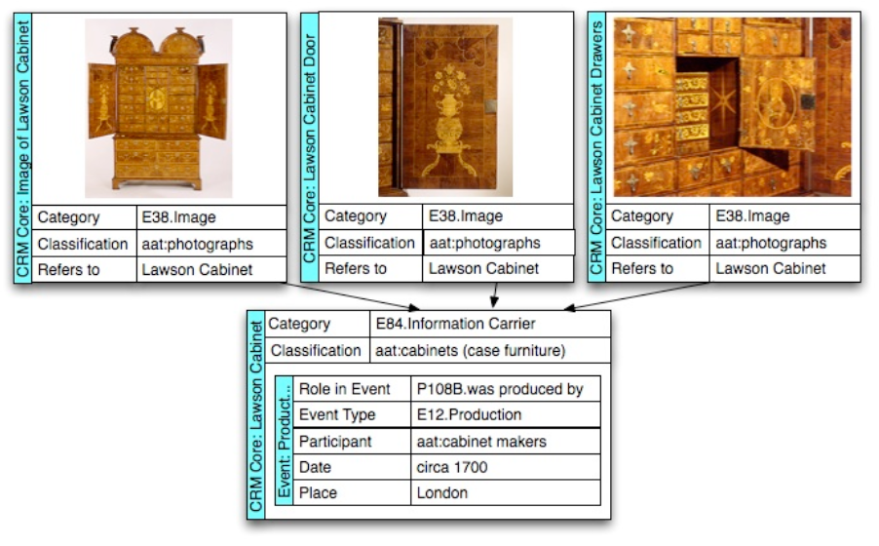
Fig. 6: CIDOC CRM scenario – Lawson cabinet (diagram reprinted from [7]).

Usage and evaluation
As a result of collaboration of the ICOM and IFLA committees it has been agreed on the harmonization of CIDOC CRM with the FRBR model. Another author describes an interconnection between MPEG7 concepts and the CIDOC CRM to provide ontology for describing museum multimedia content [10]. The CIDOC CRM model is available as an XML DTD, and it has also been formulated as RDFS and OWL ontologies.
As is obvious from last example (Fig. 6) this CIDOC CRM approach is relevant to general problem of multimedia ontology definition.

The ABC ontology and model
ABC metadata model [11] has been developed within Harmony international digital library project [12]. It aims at providing common conceptual model that can support interoperability between ontologies from different domains. Work on this model has been done in collaboration with CIMI consortium and based on number of other contacts, including the Dublin Core Metadata Initiative [13], the IFLA FRBR [1], Resource Description Framework (RDF) [14] the INDECS E-Commerce Metadata Model [15], the CIDOC/CRM Group [8]. ABC data model is documented, apart from main paper [11] in number of other conference papers and documents [12],[16],[17],[18].

ABC model was defined with following requirements in mind:

- Providing a conceptual basis for analyzing and understanding existing ontologies and metadata.
- To guide communities to begin to examine and develop descriptive ontologies.
- To develop a conceptual base for automated mapping amongst ontologies.

ABC ontology was not intended by its authors as metadata vocabulary per se, but as an ontology or model ontology that can support its users in developing specific ontologies. Therefore ABC ontology defines number of common entities and relationships – including time, object, agency, places, concepts and tangible objects. Domain ontologies developers can start with ABC ontology and extend it in area they want to cover. ABC ontology tries to comply with standard of World Wide Web consortium [19] and also tries to stay applicable to other modelling standards like UML [20] or Conceptual Graphs [21].

Leading idea behind development of ABC ontology was need to support advanced user queries that usually take place in museums and similar institutions. Such queries have often form “who was responsible for what, when and where”, so metadata model underpinning such database must provide semantic tools for capturing temporal relations, agents, actions and situations involved. Author of ABC ontology remind, that using their ontology or other complex models such as CIDOC/CRM does usually increase necessary human effort and expense in creating resource descriptions (Arms cost-functionality curve [22]).

ABC model focuses primarily on modelling temporal framework due to need to model such concepts like creation, evolution, modification or destruction of object over time. Typical users of this model are therefore museums, archives, digital libraries and right managements centres, where questions about temporal relations (when, how long) or agent relations (who created that) have high importance. ABC ontology can cover objects of various types – text, video, audio, web pages, multimedia and also abstract concepts like intellectual content, performance, of lifecycle events that are connected to some object.

Conceptual model
Basic category of ABC conceptual model is entity. Second level of ontology comprises of three categories: temporality, actuality and abstraction.

Temporality is in ABC model described by following concepts:
- Situation is used to provide the context for time dependent properties of entities. Entities can have properties that are constant and also others that exist only in context of a situation (i.e. colour of an object can change during its lifetime). Time-independent properties are bound to universal facet of an entity, while properties that time-relative are described by use of situations that are bound to existential facets of entities. In terms of first order logic existential facet corresponds to “there exists a situation in which an instance of the entity exists with this property set”, while universal facet corresponds to “for all situations in the description the entity exists with certain property set“.
- Event concept describes transition from one situation to another. Events have always time properties. So every situation has its duration, which is defined by its bounding events. Its described by via precedes and follows properties. Concept of the participation of an agent in the event is modelled by fuzzy concept of hasPresence.
- Action concept allows user to model increased knowledge about involvement and responsibility of agents in events. It can denote a verb in the context of event – hasAction property connects an action with an event.

Actuality category in ABC model is used to describe sensible entities. As have been described entity that belongs to actuality category can have one universal facet and many existential facets. Actuality is connected with a situation by property hasContext. Actuality category has subcategory Artifact that is used to describe sensible items that are tangible realization of concepts and that can be manifested in multiple ways.

Abstraction category is used to describe ideas or concepts. Entities in this category have following characteristics:

- No abstraction entity is ever in the context of situation.
- Ideas cannot exist in isolation in the model. Every idea has to be bound to some actuality using hasRealization property.

Abstraction category is used to express concept of work in FRBR sense [1]. Similarly, FRBR concepts as manifestation or item can be subsumed under ABC model concept of artifact. Fig. 7 shows hierarchy of ABC model concepts.

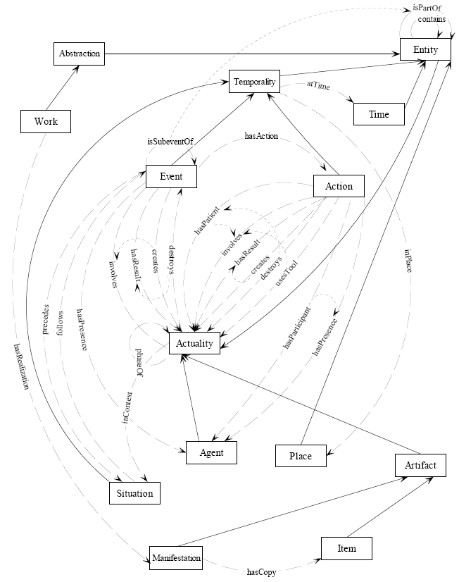

Fig. 7: ABC Class Hierarchy with Property Relationships (diagram reprinted from [11]).

Examples
ABC model authors provided following example of model use. Consider following narrative language description:

“On June 14 2001 at the Wesley Hospital, an 8lb 11oz baby girl was delivered to parents Jill and John Smith. The obstetrician at the delivery was Jane Jekyl and the midwife was Carl Hyde.” [11]

Graph representing description using ABC ontology is shown on Fig. 8.

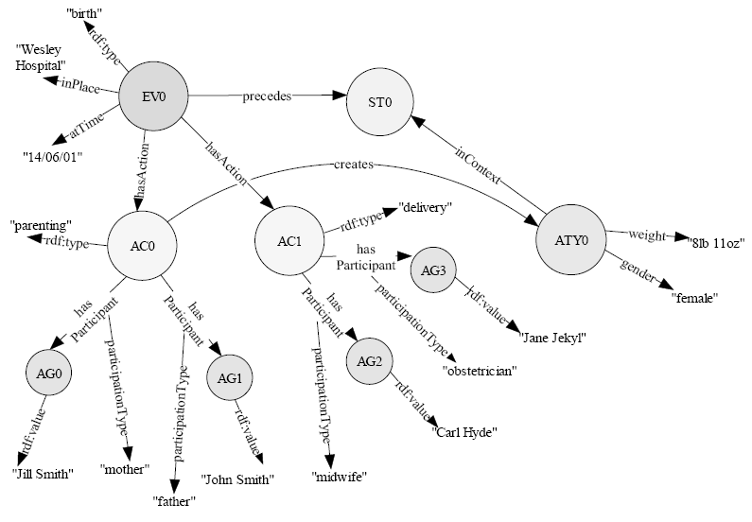
Fig. 8: Example of ABC model use (diagram reprinted from [11])

Although ABC model is syntax independent conceptual framework author provide XML/RDF syntax that can be used for encoding and exchanging metadata descriptions. If user chooses to use RDF for encoding ABC model metadata he can use number of standard tools for RDF data format. Authors of ABC model provide example of using Squish RDF Java based query engine [23]. Query for data based on ABC model metadata then can look like this example [11]:

SELECT ?event, ?type, ?time, ?place
FROM http://ilrt.org/discovery/harmony/amol.rdf
WHERE
(web::type ?event abc::Event)
(abc::context ?event ?context)
(dc::type ?event ?type)
(abc::time ?context ?time)
(abc::place ?context ?place)
USING web
FOR http://www.w3.org/1999/02/22-rdf-syntax-ns#abc
FOR http://ilrt.org/discovery/harmony/abc-0.1#dc
FOR http://purl.org/dc/elements/1.1/

Web demo for searching Squish query engine for AMOL images is publicly available [24].

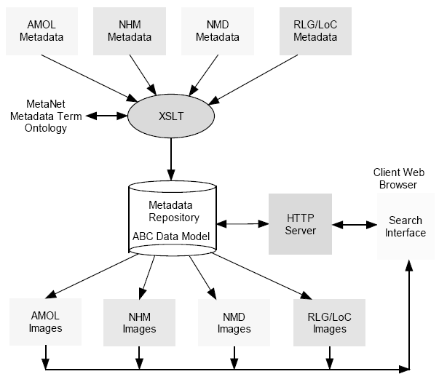
Fig. 9: ABC model experimental architecture implementation (diagram reprinted from [11])

Usage and evaluation
Authors of ABC model issued in October 2000 Call for Participation to which four institutions (CIMI members) responded: Australian Museums Online (AMOL), Natural History Museum of London, Research Libraries Group/Library of Congress, National Museum of Denmark. These institutions provided about 100 museum metadata records along with associated digital data objects. Experimental implementation was developed, shown on Fig. 9 which comprised mainly AMOL images.

Conclusion
The main goal of these common conceptual models is to facilitate interoperability between metadata ontologies from different domains. These models are not totally independent, authors of these models communicate and there is lot of inspiration of all three described models taken from others. These models also try to establish some kind of mapping between them, for example there is work [25] for mapping from CIDOC/CRM to FRBR, and also work describing mapping in opposite direction [26].

Existing foundational Ontologies

As foundational ontologies we understand such ontologies that are devoted to facilitate mutual understanding between communicating agents (human or artificial), exclusion of conceptual ambiguities and explicit representation of ontological commitments.

Foundational ontologies generally have following features [29]:
- Foundational ontologies provide a reference point for rigorous comparisons among different possible ontological approaches, and a framework for analyzing, harmonizing, and integrating existing ontologies and metadata standards.
- Foundational ontologies also provide a starting point for building new ontologies. Instead of modelling from scratch, using a foundational ontology provides us with a predefined set of ontological entities that we can reuse for the domain ontologies of K-Space. In an ideal case, the foundational ontology defines ontology design patterns for re-occurring modelling needs, such as location in space and time, that we might apply for superior design.
- Foundational ontologies also enable user to overcome typical shortcomings of commonly built ontologies.

Since first introduction of ontologies in information science research (ontology has long history in philosophy) number of foundational ontologies was created. Therefore there has been also number of classifications of foundational ontologies defined. Most important are operationalization, expressivity and specificity as they are explained in [27]:

Classification of ontologies

Classification according to operationalization is related to fact that there is trade-off between a coarse and fine-grained ontology committing to the same conceptualization. Coarse ontology uses only minimal set of axioms written in language of minimal expressivity. Drawback is that it can usually support only limited set of service developed by users that agreed on coarse ontology underlying conceptualization. Fine-grained foundational ontology uses many axioms in very expressive language, but its development can be very complex task and it can be difficult to use it for reasoning.
On this basis we distinguish between fine-grained reference ontologies and coarse shareable ontologies (or development-time and run-time ontologies).

Classification according to expressivity divides ontologies to two categories: Heavy-weight ontologies express explicitly ontological commitment and are extensively axiomatized. They focus to exclusion terminological and conceptual ambiguities. Light-weight ontology are simpler, formed by primitive or composite terms and respective definitions. They are hardly axiomatized and usually limited to terminology and structural relationship that are considered relevant.
Classification according to specificity uses three layers: generic, core and domain ontologies. These layers are not “pure” because i.e. domain ontology always uses parts of other domains, other cores etc. In generic ontology layer are concepts considered to be generic across many fields (examples: event, process, etc.) In core ontology layer are concepts that are considered generic within domain. There is no clear cut distinction between generic – core layer and also between core – domain layer. The domain ontology contains concepts that are specific for particular domain.

Ontological commitments
Every developed ontology is based on same fundamental assumptions sometimes called ontological commitments that form its implicit approach to capturing reality and general attitude towards ontological analysis. In choosing some particular foundational ontology user also chooses its internal constrains and ontological commitments. In this section we explicitly define some of these ontological choices based on analysis in [29], [30] and [31].

Particulars or universals
Ontology can cover particulars or universals. The ontological distinction between universals and particulars is usually described particulars are entities which have no instances while universals are entities that can have instances.

Descriptive vs. revisionary
A descriptive ontology tries to capture the natural language and human cognition. It is founded on the assumption that the surface structure of natural language and “common sense” are ontologically relevant.

The revisionist ontology considers language and “common sense” as secondary sources and usually paraphrases linguistic expressions when their ontological assumptions are not defensible on scientific grounds.

Multiplicative vs. reductionist
Reductionist ontological approach aims at describing a great number of ontological concepts with the smallest number of primitives. It tries to limit the actual primitives to a small subset of the concepts and reconstruct many notions in terms of these chosen primitives.

Multiplicative ontological approach focuses to developing a very expressive system and doesn’t bother about the complexity of the ontology. Its aim is to provide a reliable description of reality despite of the large number of basic concepts needed.

Possibilism vs. actualism (presentism vs. eternalism)
Actualist approach holds that only what is actually real exists. Possibilism admits also “possibilia”, entities that are not actual, but only possible, as well. Presentism holds that only what is present exists. Eternalist approach claims that the past, the present and the future are all existing.

These differences are also important from formal point of view: we can either use formal system including modal and temporal operators in designing ontology or alternatively translate modal reasoning into possible-worlds Kripke style semantics and use a first-order language with added time and world (or situation) parameters to the predicates.

3D vs. 4D
This ontological choice is related to notion of change. Three-dimensional approach holds that objects are 1) extended in three-dimensional space, 2) wholly present at each instant of their life, 3) changing entities, in the sense, that at different times they can instantiate different properties.

Four-dimensional approach claims on contrary that objects are 1) space-time worms, 2) only partially present at each instant, 3) changing entities, in sense that at different phase they can have different properties.

Alternative foundational ontologies

After short overview of the most important types of ontological choices made implicitly or explicitly by foundational ontologies, in following section we provide description and comparison of the most important foundational ontologies – BFO, DOLCE, OCHRE, OpenCYC and SUMO – based on [27], [28] and [31].

BFO
BFO (Basic Formal Ontology) was developed at Institute for Formal Ontology and Medical Information Science (IFOMIS) by team lead by Barry Smith at the University of Leipzig.

BFO is formed by number of sub-ontologies that can be linked together by formal relations. Every subontology has different level of granularity, BFO also contains specific subontologies for endurants and for perdurants. BFO is based on a realistic ontological bias.

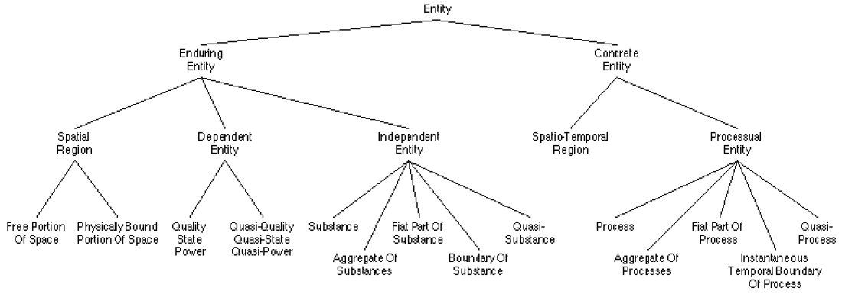
Figure 10: BFO core concepts.

DOLCE
Foundational ontology DOLCE (Descriptive Ontology for Linguistic and Cognitive Engineering) was developed by ISTC-CNR as a reference module for a library of ontologies for the WonderWeb Project. DOLCE is based on OntoClean methodology [32], which is devoted to definining formal constraints for ontology-building.

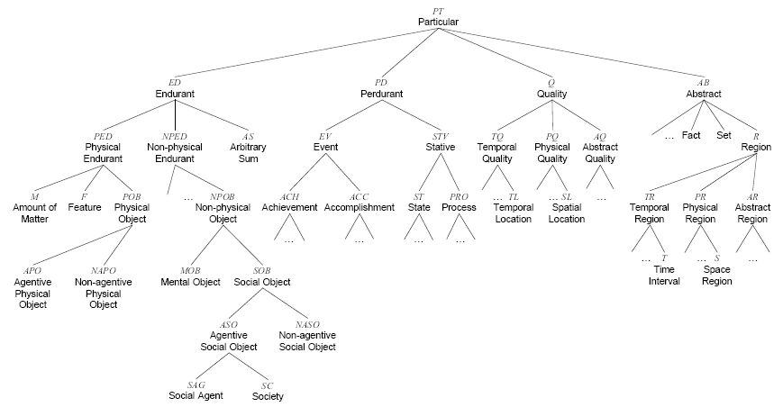

Figure 11: DOLCE top level ontology.

DOLCE explicitly states its cognitive bias: it aims at capturing the ontological categories underlying natural language and human common sense. DOLCE also uses multiplicative approach: it assumes that different entities can be co-located in the same space-time. DOLCE ontological commitments are based on primitive formal relations, such as parthood, dependence and constitution that are believed to be as neutral as possible. DOLCE also provides an extended axiomatization, which is useful for the area of the Semantic Web. There is also an alignment of DOLCE with WordNet.

OCHRE
OCHRE (Object-Centered High-level Reference ontology) aims at combining descriptive adequacy for commonsense with formal economy in the basic categories and their axiomatization [31]. OCHRE is ontology of particulars, because it does not include universals, i.e. repeatable properties.

OCHRE is an also object-centered ontology. That means that certain bundles of tropes, specifically those exhibiting spatial and temporal features as well as their enduring cores, are considered having a privileged ontological status over other particulars.

OCHRE is clearly extensionalist ontology. Firstly: it adopts extensionalism regarding parthood, that means that particulars with the same parts are considered to be the same. Secondly: it uses extensionalism with respect to spatial extent, insofar as no two spatial objects can be coincident.
OCHRE rejects the multiplicative approach: it describes spatial objects as having various qualitative aspects or “guises”.

OpenCYC
The CYC project started at MCC (Microelectronics and Computer Consortium) and originally aimed to develop a computer program “equipped” with a large amount of commonsense knowledge.

CYC comprises hundreds of “microtheories” (contexts), specifically bundles of assertions that share common assumptions about the world. A “microtheory” in CYC system usually concerns a specific domain of knowledge Problems of consistency can arise when CYC deals with several microtheories at the same time.

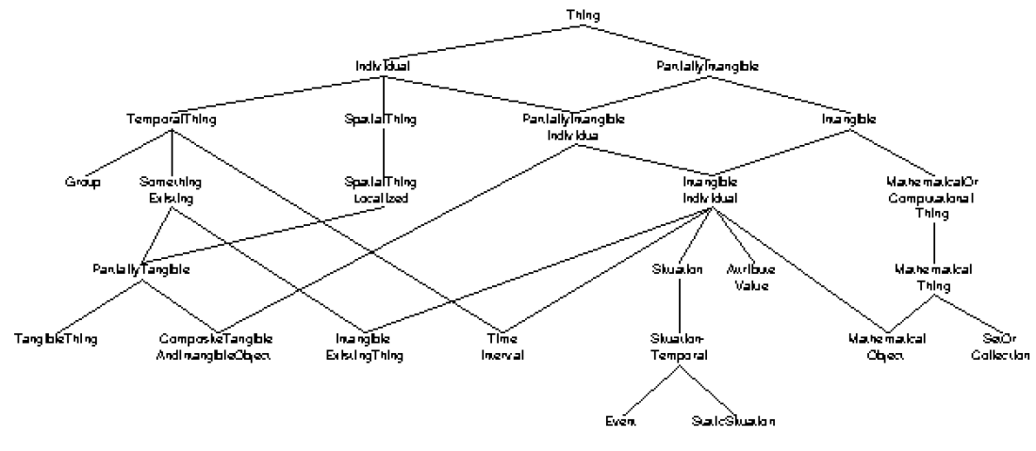
Figure 12: OpenCYC top level ontology.

CYC is a very huge system containing thousands of everyday terms that has complex architecture. For our purpose we focus on the foundational part of the project: OpenCYC ontology. This part of the project is publicly available.

OpenCYC has clear cognitive bias, its ontological categories try to capture naïve conceptions of the real world. Purpose of project is capturing whole human fund of common sense knowledge so its clearly the product of a multiplicative conceptualisation of reality. OpenCYC contains about 5000 concepts and 50000 axioms, subdivided in microtheories. It supplies minimal general foundational categories and provides links to natural language, using Wordnet’s synset structure.

SUMO
The SUMO (Suggested Upper Merged Ontology) was developed by the IEEE Standard Upper Ontology (SUO). It aims at linking categories and relations coming from different top level in order to improve interoperability, communication and search in the Semantic Web area. SUMO is internally divided in 11 modules. These are complementary ontologies grouping categories by topics.

Entity
Physical
Abstract
Object
Process
SetOrClass
Relation
Quantity
Atribute
Proposition
Number
Physical Quantity
Internal Change
Intentional Change
DualObject Process
ShapeChange
Motion
SelfConnected Object
Region
Collection
Agent

Figure 13: SUMO top level ontology

SUMO is not influenced by a specific theoretical approach, because it aims at merging of different upper level ontologies. It takes from various ontological proposals those general categories which seem to be largely shared by the computer science community. SUMO therefore does not clearly adopt neither a multiplicative nor a reductionist approach. It also contains some axiomatization and it has been linked with WordNet 1.6.

KR Ontology
KR ontology has been developed by J. F. Sowa and was influenced by philosophical works of Ch. S. Peirce and A. N. Whitehead [33]. Its basic categorisation is based on relation, substance and time. He considers three types of categories based on relations: independent, relative, mediating; two types of substance: physical and abstract; two categories according to time: continuant and occurent.

Based on this top level categorisation he defines twelve basic categories as combination of them:

 | Physical |  | Abstract
 | Continuant | Occurrent | Continuant | Occurrent
Independent | Object | Process | Schema | Script
Relative | Juncture | Participation | Description | History
Mediating | Structure | Situation | Reason | Purpose

This structure of his ontology is also depicted on figure 14:

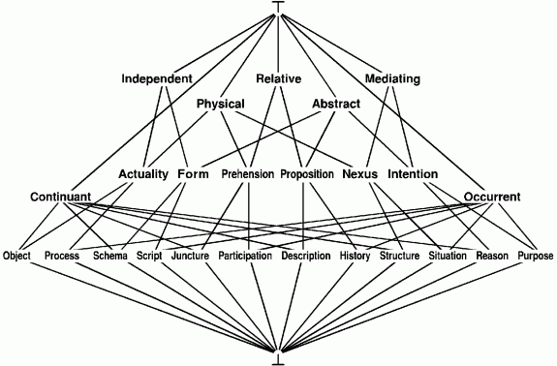
Figure 14: Top level categories of KR ontology.

Due to its reductionist and revisionist approach is not KR ontology too popular in Semantic Web community. Ontologies more close to common sense understanding are usually preferred.

Conclusion

K-Space project focuses on using Knowledge web technologies together with multimedia analysis technologies. It brings together experts specialised in various research areas – ontology engineering, audiovisual data analysis, linguistic analysis etc. The character of K-Space project defines the features of foundational ontology that should be used.

K-Space domain ontologies will usually model some areas of common sense so the foundational ontology should preferably be descriptive. Consequence of descriptive approach is also preference of multiplicative foundational ontologies that are usually closer to human common sense. For purpose of K-Space project it is not neccessary to consider possibilia, possible objects or modalities, and it would unnecessarily raise complexity of ontology. As result an ontology based on actualism can be used. Audiovisual character of analysed data also brings requirement of ability of ontology to deal with time category. Ontology should therefore be 4D. Foundationl ontology should be also based on W3C standards, preferably available in OWL (Web Ontology Language) format. As we can see on included table DOLCE ontology meets most defined requirements of K-Space project.

Requirement / Ontology | BFO | DOLCE | OCHRE | OpenCYC | SUMO | KR Ontology
Descriptive | no | yes | no | yes | yes | no
Multiplicative | no | yes | ? | ? | ? | no
Possibilistic | no | yes | yes | ? | ? | ?
Pendurantic | yes | yes | no | ? | ? | yes
4D | yes | yes | yes | ? | no | yes
OWL | no | DL | no | yes | no | ?

References

[1] IFLA. Functional Requirements for Bibliographic Records, UBCIM Publications – New Series Vol. 19. http://www.ifla.org/VII/s13/frbr/frbr.pdf.

[2] James Martin. Strategic Data-Planning Methodologies. Prentice-Hall, 1982.

[3] Graeme Simsion Data Modeling Essentials. Van Nostrand Reinhold, 1994

[4] Richard Perkinson Data Analysis: the Key to Data Base Design. QED Information Sciences, 1984

[5] Ramez Elmasri, Shamkant Navanthe. Fundamentals of Database Systéme Benjamin/Cummings, 1989.

[6] Visual Resources Association Data Standards Committee, VRA Core Categories, Version 3.0. http://www.vraweb.org/vracore3.htm

[7] Patrick Sinclair, Matthew Addis, Freddy Choi, Martin Doerr, Paul Lewis and Kirk Martinez. The use of CRM Core in Multimedia Annotation. To appear in SWAMM 2006.
http://image.ntua.gr/swamm2006/resources/paper16.pdf

[8] CIDOC CRM Core demonstrations. http://cidoc.ics.forth.gr/crm_core/demo/

[9] Doerr, M.: The CIDOC Conceptual Reference Model: An ontological approach to
semantic interoperability of metadata. AI Magazine, 24 (2003) 75–92.

[10] Hunter, J. Combining the CIDOC CRM and MPEG-7 to Describe Multimedia in
Museums. Museums on the Web 2002, Boston, April 2002.

[11] Carl Lagoze and Jane Hunter. The ABC Ontology and Model. Journal of Digital Information, Volume 2 Issue 2. Article No. 77, 2001-11-06

[12] The Harmony Project. http://metadata.net/harmony.

[13] Dublin Core Metadata Initiative. http://dublincore.org.

[14] O. Lassila and R. R. Swick, Resource Description Framework: (RDF) Model and
Syntax Specification. World Wide Web Consortium, W3C Proposed Recommendation PR-rdf-syntax-19990105, January 1999. http://www.w3.org/TR/PRrdf-syntax/.

[15] INDECS Home Page: Interoperability of Data in E-Commerce Systems, http://www.indecs.org/.

[16] D. Brickley, J. Hunter, and C. Lagoze, ABC: A Logical Model for Metadata Interoperability. Harmony Project, Working Paper 1999. http://www.ilrt.bris.ac.uk/discovery/harmony/docs/abc/abc_draft.html.

[17] J. Hunter and D. James, Application of an Event-Aware Metadata Model to an Online
Oral History Archive. Presented at ECDL 2000, Lisbon, 2000, http://archive.dstc.edu.au/RDU/staff/janehunter/OralHistory/paper.html

[18] J. Hunter and C. Lagoze, Combining RDF and XML Schemas to Enhance Interoperability Between Metadata Application Profiles. Presented at WWW10, Hong Kong, 2001, http://www.cs.cornell.edu/lagoze/papers/HunterLagozeWWW10.pdf.

[19] World Wide Web Consortium. http://www.w3c.org

[20] G. Booch, J. Rumbaugh, and I. Jacobson, The unified modeling language user guide. Reading Mass.: Addison-Wesley, 1999.

[21] J. F. Sowa, Conceptual Graphs, 2001. http://www.bestweb.net/~sowa/cg/.

[22] ICOM/CIDOC Documentation Standards Group, CIDOC Conceptual Reference Model, 1998. http://www.villege.ch/musinfo/cidoc/oomodel/.

[23] L. Miller, RDF querying using Squish, 2000. http://swordfish.rdfweb.org/rdfquery/.

[24] RDF: Image Metadata, 2001. http://swordfish.rdfweb.org/discovery/2001/03/demos/image.html.

[25] Mapping CRM => FRBR
http://homepages.cwi.nl/~troncy/tmp/mapping_crm_frbr.pdf

[26] Mapping FRBR => CRM
http://homepages.cwi.nl/~troncy/tmp/mapping_frbr-crm_revised.pdf

[27] P. Cimiano, A. Eberhart, P. Hitzler, D. Oberle, S. Staab, R. Studer. The smartweb foundational ontology. SmartWeb Project Report 2004.
[28] D. Oberle. Semantic Management of Middleware. Springer 2005.

[29] M. Romanelli, P. Buitelaar, R. Engel, D. Sonntag, N. Reithinger, B. Loos, R. Porzel, H.-P. Zorn, V. Micelli, C. Schmidt, M. Weiten, F. Burkhardt, J. Zhou. DOLCE ergo SUMO: On Foundational and Domain Models in SWIntO (SmartWeb Integrated Ontology). Technical Report , AIFB, University of Karlsruhe. July 2006.

[30] C. Masolo, S. Borgo, A. Gangemi, N. Guarino, A. Oltramari, L. Schneider. WonderWeb Deliverable D17. The WonderWeb Library of Foundational Ontologies. http://wonderweb.semanticweb.org/deliverables/D17.shtml

[31] C. Masolo, S. Borgo, A. Gangemi, N. Guarino, A. Oltramari. WonderWeb Deliverable D18. Ontology Library. http://wonderweb.semanticweb.org/deliverables/D18.shtml

[31] S. Borgo, A. Gangemi, N. Guarino, C. Masolo, A. Oltramari. WonderWeb Deliverable D15. Ontology Roadmap. http://wonderweb.semanticweb.org/deliverables/D15.shtml

[32] A. Oltramari, A. Gangemi, N. Guarino, C. Masolo. Restructuring WordNet's Top-Level: the OntoClean approach. In Proceedings of OntoLex2002: Workshop on Ontologies and Lexical Resources. Las Palmas, Canary Islands.2002.

[33] J. F. Sowa. Knowledge Representation. http://www.jfsowa.com/ontology
[APPENDICIES – as appropriate]

